28.49: Let the wire connected to the 25.0  resistor be #2 and the wire connected to the 10.0 resistor be #1. Both 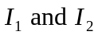 are directed toward the right in the figure, so at the location of the proton 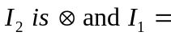⊙

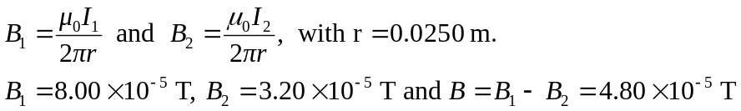
and in the direction ⊙.

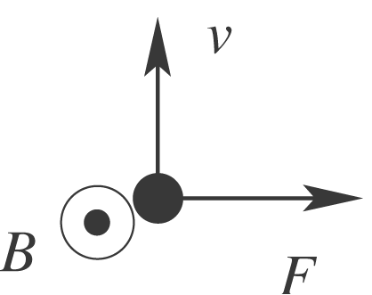 Force is to the right.

